Requirement :
. What the client (trader) needs.
- Reports on individual stock
- Report on comparing the stock with other
- Report the

- Individual stock assessment
- grouping by country, geography
- market segment
-
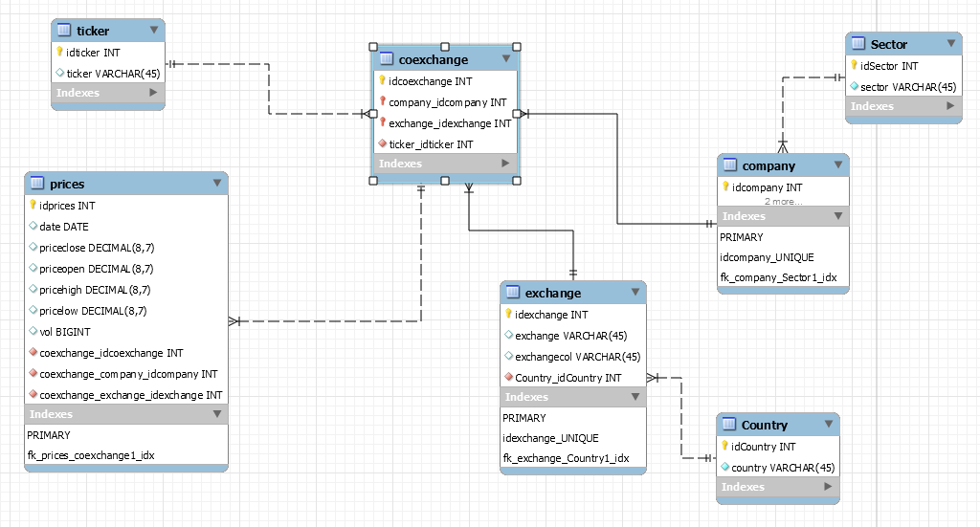

Yahoo Finance
coExchange
- idCoexchange
- exchange
- company
- ticker
stockPrices
- idPrice
- priceOpen
- priceClose
- priceLow
- priceHigh
- vol
- idcoexchange
Session Beans

- quoteStock
- chart
- add/delete stock
- top 10 performance
- top 10 gainer
- top 10 loser
- compare
-- basket
-- multiple
-- market/sector
- historical data

Provide real time data
user
Request for the data

